# IPND - Proposed Infrastructure and Support Model

Following are the key components of the proposed serverless architecture.



All services except Aurora Serverless are being used across various Telstra applications.  
Using Aurora Serverless has minimal risk as Aurora is being used extensively. Aurora Serverless just provides an on-demand, auto-scaling configuration for Amazon Aurora which automatically starts up, shuts down, and scales capacity up or down based on application's needs. It is especially suitable for infrequent, intermittent, or unpredictable workloads like IPND Batch Processing.

***Note****: Based on PoC outcome, we might arrive at a hybrid solution using Serverless, PaaS and IaaS components to minimise the risk of extensive code re-factoring.*

LogicalTech will continue to provide all levels of application support like in the current arrangement but will have reduced infrastructure management responsibility as shown below. Estimated reduction in operational support costs is valued at **>100k** per annum

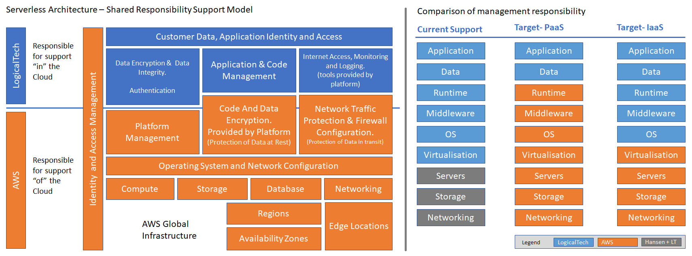

Comparison of Infrastructure Costs – IaaS vs Serverless (Indicative):

